**Kolhapur Institute of Technology’s**

**College of Engineering (Autonomous), Kolhapur**

**Department of Computer Science and Engineering,**

**SEM- IV,**

**AY: - 2022-23**

**“Automatic Dual Solar Orientation’’**

**A Report** Submitted

in Fulfilment of the Requirements

for the

**Second Year BTech. of CSE**

Under the subject

**Mini Project Lab**

by

|  |  |  |
| --- | --- | --- |
| Sr. No | Name | Roll no. |
| **1** | **Sagar Salgar** | **A49** |
| **2** | **Arya Kumbhar** | **A53** |
| **3** | **Vaishnavi Waghmare** | **A76** |
| **4** | **Radhika Kumbhar** | **A80** |

**CERTIFICATE**

This is to certify that, the project entitled “Automatic Dual Solar Orientation System”,

has been satisfactorily completed by,

|  |  |  |
| --- | --- | --- |
| 1. | Sagar Salgar | (A49) |
| 2. | Arya Kumbhar | (A53) |
| 3. | Vaishnavi Waghmare | (A76) |
| 4. | Radhika Kumbhar | (A80) |

The students of SY B.Tech of Division A, Department of computer Science & Engineering , in fulfilment of Mini project for the semester – IV of academic year 2022-2023.

This project report is a record of student’s own work carried by him/her under my supervision and guidance in satisfactory manner.

Date:

**Prof. Dr. Ajit S. Patil**

**(HOD, CSE Department)**

**Miss. Shubhada Sawakhande**

**(Assistant Professor)**

**Director**

Kolhapur Institute of Technology’s College of Engineering, Kolhapur. Year 2022- 23

**Acknowledgement**

We are grateful to Mr. Ajit S. Patil , HOD CSE Department, KIT’s College of Engineering, Kolhapur, for providing this opportunity to conduct the Project at CSE Department. We would like to expresses our gratitude to other faculty members of CSE Department for providing academic inputs, guidance & encouragement throughout this period. We would like to express a deep sense of gratitude.

Also, We express our sincere gratitude and thanks to Miss. Shubhada Sawakhande Ma’am, for providing us the excellent opportunity to do a project on ‘Automatic Dual Solar Orientation System ’ and providing us with all the essential elements required for the completion and enhancement of this project. We would like to thank those respondents who have taken pain in successful completion of our project work. Finally, We express our indebtedness to all those who have directly or indirectly contributed to the successful completion of our project.

**1.Abstract: -**

This project aims to develop dual axis solar tracker with IOT monitoring system using Arduino. Generally, solar energy is the technology to get useful energy from sunlight. Solar energy has been used in many traditional technologies over the centuries and has been widely used in the absence of other energy supplies. The solar tracking system is the most effective technology to improve the efficiency of solar panels by tracking and following the sun's movement.

With the help of this system, solar panels can improve the way of sunlight detection so that more electricity can be collected as solar panels can maintain a sunny position. Thus, the project discusses the development of two-axis solar-tracking developers using Arduino Uno as main controller the system.

**KEYWORDS**- Arduino, sensor, Servo motor, Simulation,

**2.Introduction: -**

With the increase in production of the green energy systems, we need effective measures to harness the green measures, to utilize the green energy with its full power.

There are multiple ways for us to increase the efficiency of the solar energy panels which are just placed in standard rigid position.

**WHAT IF THEY ACT LIKE A SUNFLOWER?**

We also know that Sunflowers face the rising sun because increased morning warmth attracts more bees and helps the plants reproduce more efficiently.

This application can also be applied in the solar powered projects in solar panels.

Thus, we can move solar panels in an axis facing the sun to change the receiving angle of the sun rays to greatly utilize the sun energy and make a higher output electricity generation.

**Design Implementation of Automatic Dual Solar Orientation**

The figure shown below shows the development life cycle of Radar project which involves various step such as design of different components, their testing, their implementation and implementation of entire system and their testing. These steps can be enumerated into following stages

a) Hardware System Design.

b) Hardware Circuit Design.

c) Hardware System implementation.

d) Hardware unit testing.

e) GUI System Design.

f) GUI System Implementation.

g) GUI unit testing.

h) Entire system integration.

i) Entire system testing.

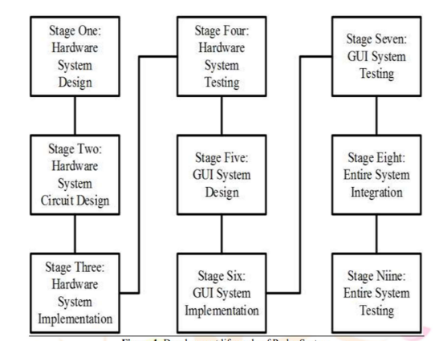

**Fig 1. https://www.researchgate.net/figure/Development-life-cycle-of-Radar-System_fig1_354715482**

**3. System Analysis:**

First part explains about the process to develop of dual axis solar tracker. Next, the software and hardware development will discuss in detail.

**3.1 Process of dual axis solar tracker:**

This project has monitored the performance of solar tracker system by using internet of things. In this project also divide into two parts, Firstly, the software development and secondly is the hardware development.

The Figure 1 shows the block diagram of system. The system is starts with the sensors detectedthe sun position and send the data to an Arduino. After that the Arduino process the information from the sensor to command the 180-degree servo motor that hold the photovoltaic to move toward the sun. Next, the photovoltaic gather the energy from the sun and charges the battery and send the value to the Arduino.

Lastly, the Arduino will send the data that has been taking by photovoltaic to WIFI module and send to the IOT monitoring system for records as shown in Figure 1. The IOT monitoring system will be update the data after some time.

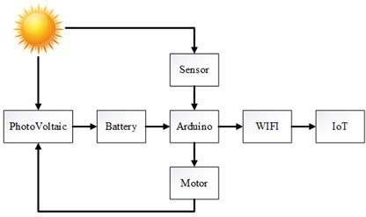

**Fig 2. Process of solar tracker system**

**https://pdfs.semanticscholar.org/e208/d811638b8a40432e60152128c25174285b66.pdf**

**3.2 Problem Definition: -**

To design and implement an automated, double solar tracking mechanism using embedded system design in order to optimize the efficiency of overall solar energy output.

**4. System circuit design**

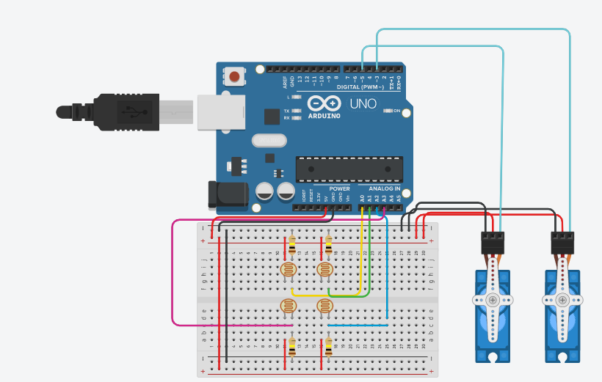

**Fig 3. Breadboard Connections**

**4.1 Working Principle:**

Automatic Solar Orientation System Using Arduino.

The working principle of solar orientation using Arduino involves using light sensors to detect the sun's position and servo motors to adjust the alignment of a solar panel accordingly. The Arduino board collects data from the light sensors, calculates the deviation between the current and desired alignment, and controls the servo motors to move the panel in the appropriate direction. This process is repeated periodically to ensure the solar panel continuously faces the sun for optimal energy absorption**.**

**LDR**

**Fig 4. Basic flow of working**

**5.Hardware and Software Requirements:**

**5.1Hardware Used**

* Solar panel
* LDR sensors
* Servo Motor (SG90)
* Resistors (10k)
* Jumper wires
* Arduino UNO
* ESP8266 Module

**5.1.1 Servo motor:**

A servomotor is a rotary actuator that allows for precise control of angular position, velocity, and acceleration. It consists of a suitable motor coupled to a sensor for position feedback. It also requires a relatively sophisticated controller, often a dedicated module designed specifically for use with servomotors. Servomotors are not a different class of motor, on the basis of fundamental operating principle, but uses servomechanism to achieve closed loop control with a generic open loop motor. Servomotors are used in applications such as robotics, CNC machinery or automated manufacturing.

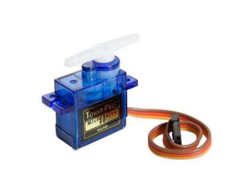

**Fig 5. Servo Motor**

**5.1.2 Arduino :**

The Arduino is an open source electronics platform based on easy to use hardware and software. The open source Arduino software makes it easy to write code and upload it to the board. It runs on Windows, Mac OS X and Linux. The environment is written in java and based on processing and other open source software. This software can be used with any Arduino board. The Arduino software IDE contains a text editor for writing code, a message area, a text console, a toolbar with buttons for common function. It connects to Arduino and Genuino hardware t+o upload programs and communicate with them. Program written using Arduino software are called sketches Bread board Breadboards are one of the most fundamental pieces when learning how to built.

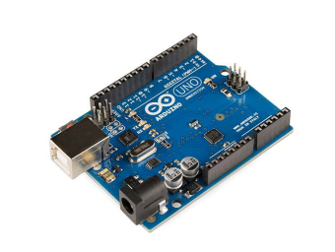

**Fig 6. Arduino Board**

**5.2 Software Used**

* HTML
* Javascript
* CSS
* XAMPP
* Arduino IDE
* Arduino web Editor
* Arduino wifi Web Client

**6.Screenshot of Hosted Website:**

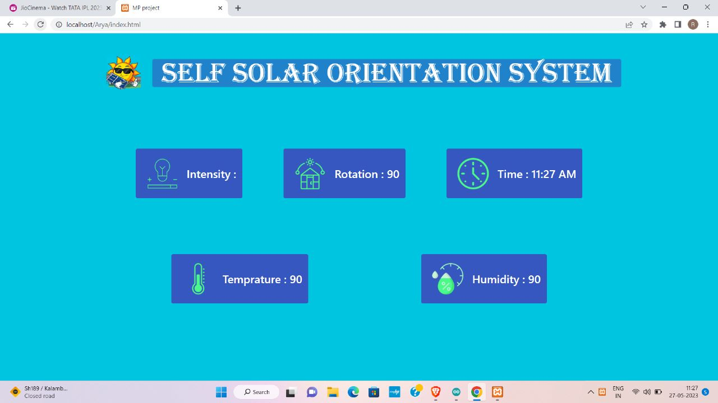

**Fig 7. User Side information display In web**

**Conclusion:**

In conclusion, the development of an automatic dual solar orientation system using Arduino brings numerous benefits and advancements in solar energy harvesting. This system utilizes the capabilities of Arduino microcontrollers to accurately track and adjust the position of solar panels in real-time, maximizing their exposure to sunlight throughout the day.

summary, the automatic dual solar orientation system using Arduino presents a practical and efficient solution for maximizing solar energy harvesting. Its ability to track and adjust solar panels in real-time, combined with the affordability and versatility of Arduino microcontrollers, makes it a valuable technology for promoting renewable energy adoption and enhancing the overall efficiency of solar power systems

**References:**

1. Ghaffarianhoseini, A., Ghaffarianhoseini, A., & Abbott, M. (2015). Solar tracking systems: Technologies and trackers comparative study for high latitudes areas. Renewable and Sustainable Energy Reviews, 41, 1275-1288.

2. Li, H., & Wang, L. (2014). Arduino-based solar tracking system using light-dependent resistors. In 2014 IEEE Conference and Expo Transportation Electrification Asia-Pacific (ITEC Asia-Pacific) (pp. 1-4). IEEE.

3. Kumar, S., & Jain, V. (2015). Design of Arduino based solar tracking system. International Journal of Innovative Research in Science, Engineering and Technology, 4(5), 3457-3462.

4. Chaturvedi, A., & Singhal, S. (2018). Design and implementation of dual axis solar tracking system using Arduino. In 2018 International Conference on Power, Instrumentation, Control and Computing (PICC) (pp. 1-4). IEEE.

5. Dutta, S., Guinn, R., & Das, R. (2019). Arduino based dual axis solar tracking system for maximum power generation. In 2019 3rd International Conference on Power and Renewable Energy (ICPRE) (pp. 23-28). IEEE.

6. Images from site: https://www.researchgate.net/figure/Development-life-cycle-of-Radar-System_fig1_354715482